**Middleware**

* Body-parser: Parses the body of the HTTP requsts to JSON format.
* Fs – allows you to use the file system of the server.
* Mongoose – abstraction for talking to MongoDB.
* Passport – authentication service for Node.js

App.use á middleware.. NOTAÐ ALLSTAÐAR.. annars bara..

App.post(‚/movies‘, bodyParser.json(), (req, res) => { }); //etc

TODO schema.. mongoos.e.

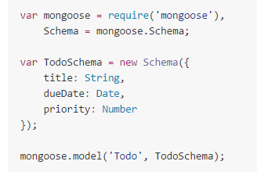

Have Schema.. need to add some operations..

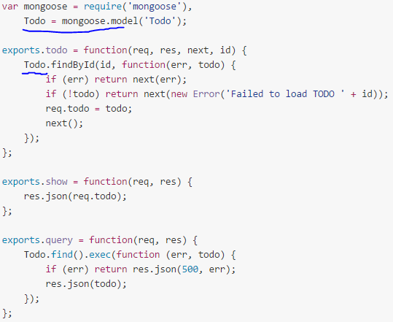

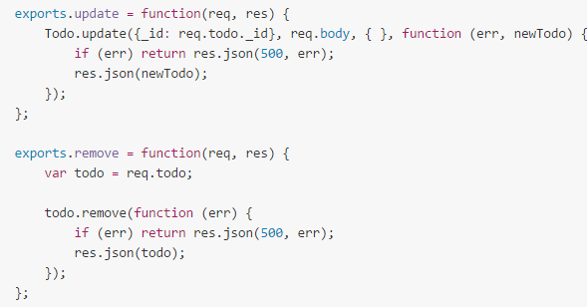

Have defined CRUD on our TODO schema..

MAP OUR FUNCS TO ROUTES.. checkout routes.js file...

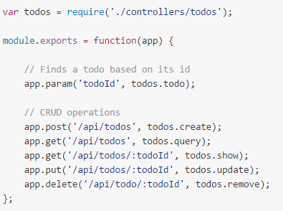

App.param.. works as middleware to the request.. **fetches the record based on the todoId** and relays that record to the ACTUAL functions

Bring it all together:

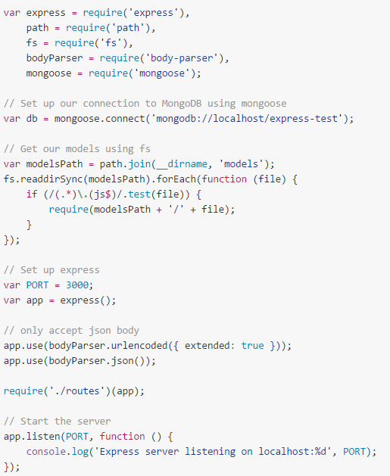

With Mongoose.. everything is derived from a **Schema**..

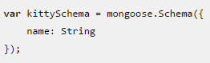

Next we compile our schema into a Model..



A **model** is a class with which we **construct documents**.. each document will be a kitten with properties and behaviors as declared in our schema...



Kittens can meow.. add that:

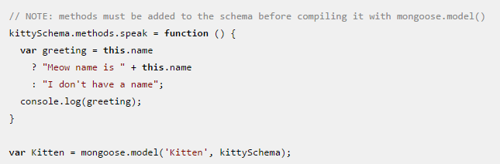



**We can access all of the kitten documents THROUGH THE KITTEN MODEL**

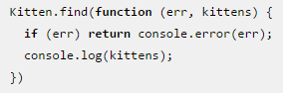

Can also query..

